**Exp 4 SmartPhone Control Led**

**Circuit Diagram**

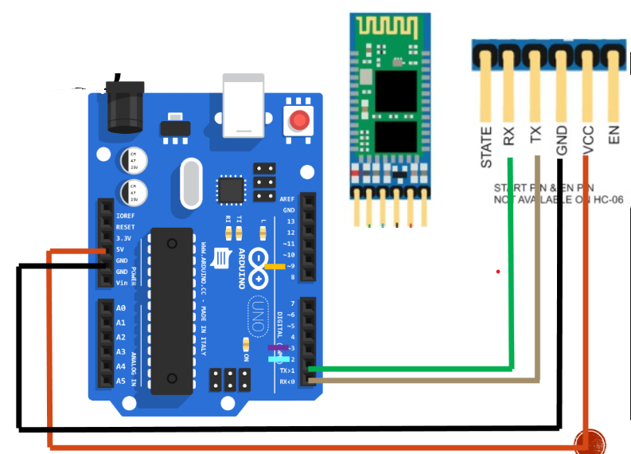

**Theory**

**Bluetooth-HC**

1. It is used for the communication between smartphone and microcontroller.
2. It operates on low power i.e.1.8 v operation.
3. Using Bluetooth profile and android platform architecture different types of Bluetooth module can developed.

**Concepts Used**

1. Interfacing the Bluetooth with the Arduino and led.
2. Blinking Of Led concept used.
3. Concept of Condition Statement used.
4. Concept of serial.begin used.
5. Concept of pins of Bluetooth is used.

**Learnings and Observations**

In this experiment we learnt the following:

1. Basic circuit building with Arduino uno.
2. Interfacing an LED with Arduino uno.
3. Interfacing a bluetooth with led and Arduino.
4. Control the led with the help of the smartphone.
5. Interfacing the smartphone with the led with the help of bluetooth.

We observe the following things:

1. When we press the ON switch from our smartphone the red led will turn ON.
2. When we press the OFF switch from our smartphone the led will turn OFF.

**Precautions**

1. Don’t make the connection loose.
2. Before uploading the code into the Arduino make sure that the circuit is correct to avoid the damage of the circuit
3. Check the led are working or not with the help of the multimeter.
4. The LED should not be connected in reversed direction because it doesn’t allow passing the current and circuit does not completed and LED will not glow.
5. Make sure that the Bluetooth you are using is connected with your device only i.e. your smartphone.

**Learning Outcomes**

1. **We learn that how we can control the led from our smartphone seating in the one corner of the room while the led in another corner of the same room.**
2. **We also learn that how to interface a led , Arduino, and Bluetooth in the circuit.**
3. **We also get to know the function of the “serial.begin”.**
4. **We also learn how to connect the led with the smartphone with the help of bluetooth.**